*User Manual*

*Purpose*

* Here is a step-by-step guide on how to navigate through the Limestone County 911 website and understand all its functionalities and what they do. The user will need to navigate to <http://www.alc911.org/> using any browser he or she chooses.

*GIS MAP*

* The geographic information system map is used to assist the 911 center in directing local law enforcement and emergency medical personal in the location of where the call is made.



The user can click on the GIS tab and the map will then open in a new window. This will allow the user to zoom in and out and rotate the map as needed.

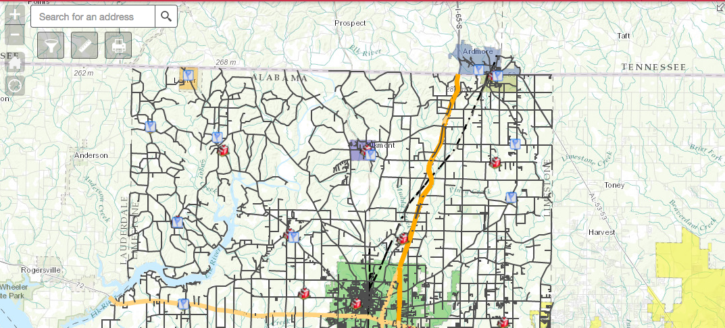

*Smart 911 Link*

* Smart 911 is an automated delivery of a Safety profile with personal and medical information that will better assist emergency personal during a 911 call. Limestone County is the only county in North AL to utilize this feature and is one of only six counties out of the state.

By clicking on the smart 911 tab the user has three YouTube videos to choose from. The first video is a tutorial on how to sign up for Smart 911. The second video gives a brief description of the advantages of signing up for Smart 911. The third video is an introduction of the rave panic button and explains how it works.



When clicking on the Smart 911 link it will open to a new page and allows the user to sign up for a personal account.

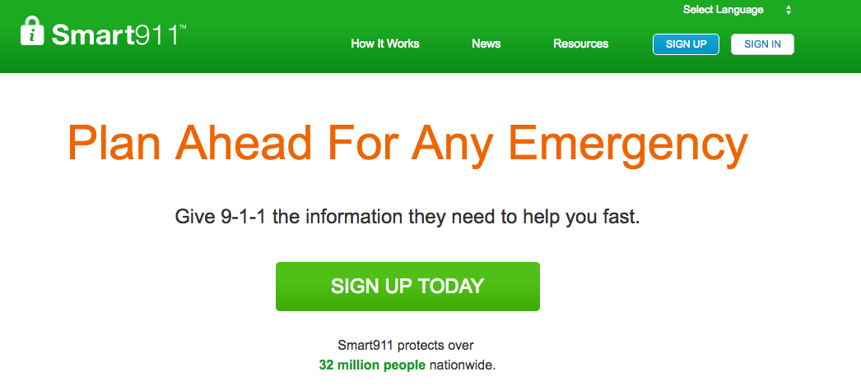The Smart 911 Facility will allow the user to create an account for a business or organization.

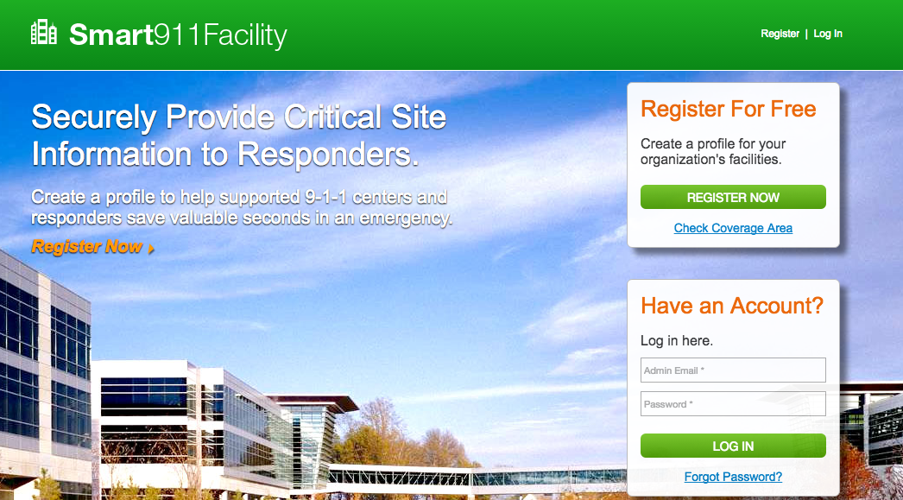

*Links*

* The links tab will open in a new window and will give a list of local news stations to choose from. It will also have links to other emergency facilites such as the Limeston County Hospital, the Sherrifs office, Police department, etc.

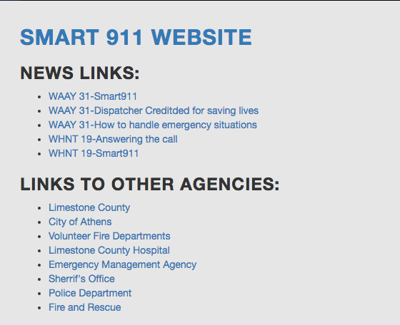

*Forms*

* There are two forms that are available on the site, an address request form and job application form. If the user clicks on the addressing tab the user will get a brief description of how the addressing system works.

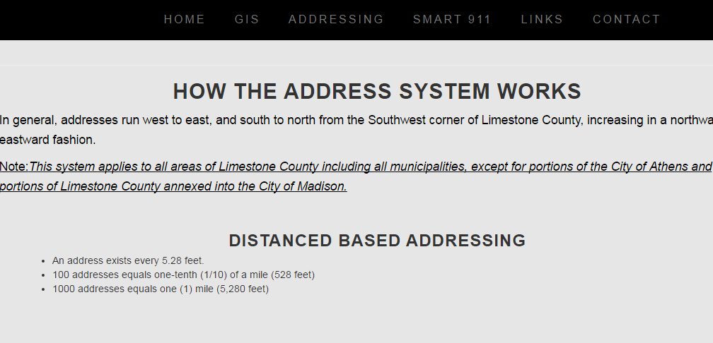

The user can then scroll to the bottom and click on this link and it will open the address request form.

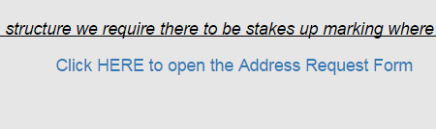

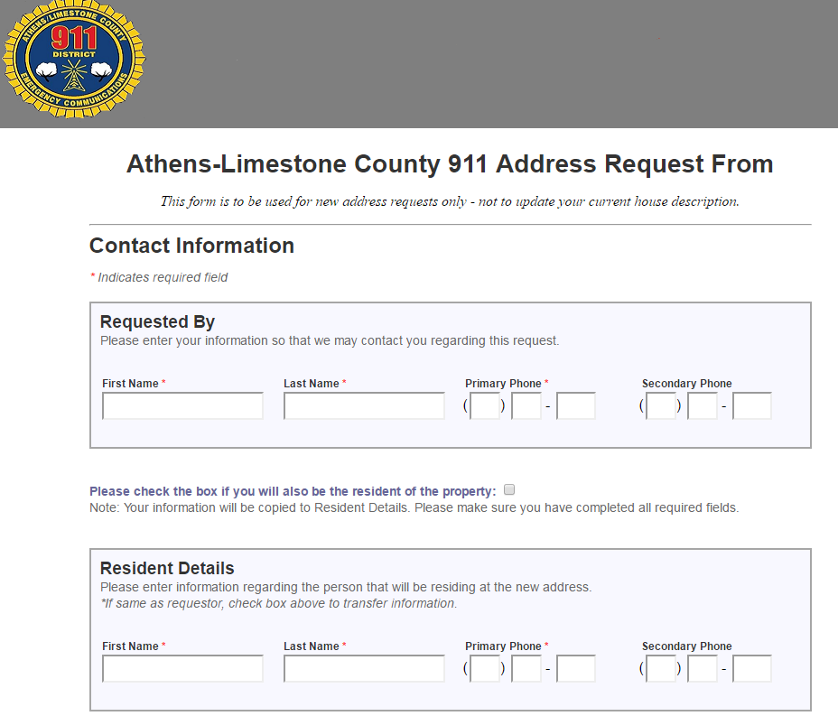

*Contact*

* The contact link contains the phone number, address, e-mail address and a GIS map location for the 911 facility. The online and PDF version of the job application along with instructions how to fill it out are also located under this tab.

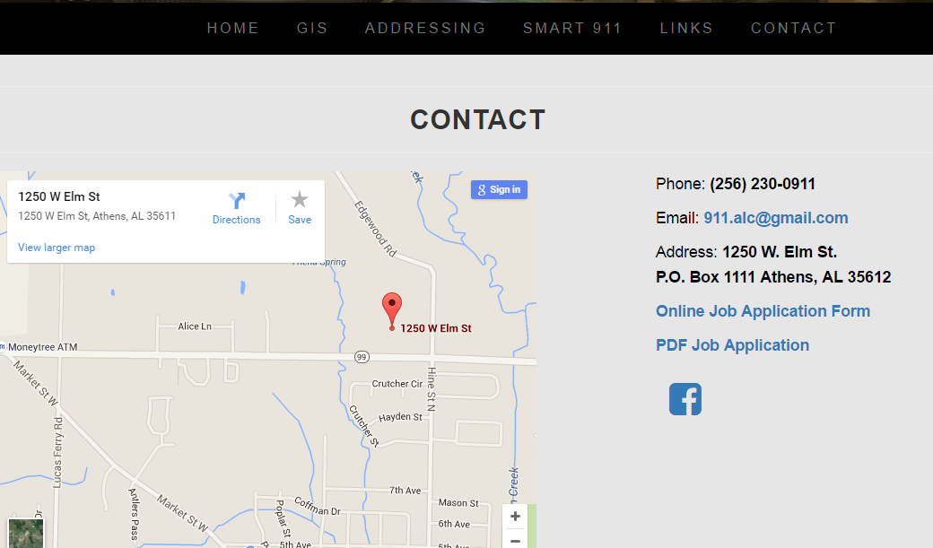

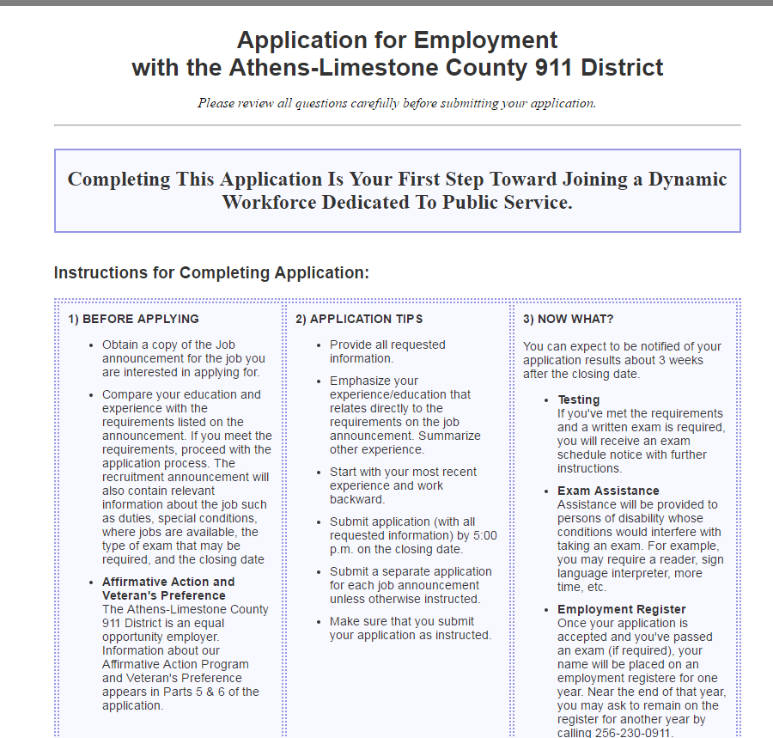

Once the forms have been submitted an e-mail is then sent to the administrator

containing the information.

